***Groningen vs Leeuwarden***

# Problem

Within the Netherlands, every province has a capital. For Groningen, it is conveniently called Groningen, and for Friesland, it is called Leeuwarden. Within both cities, it is a running joke to compare both provinces to each other and decide which one is better. This research project, we will not answer the question which one is better.

Nevertheless, it will try to determine which province has the best venues. Therefore, the main question that will get answered is:

*By comparing Groningen and Leeuwarden, which city has the best venues for its population.*

The following three criteria will determine the victor.

|  |
| --- |
| Assessment criteria |
| 1. Quality of the venues 2. Diversity of the venues 3. Average prince-point of the venues |

To conclude which city performs better based on venues is determined by these criteria. To be able to take away the prize, a city is required to become a victor in 2 out of 3 criteria.

# Data and methods

## The geographical framework

For this project, the data gathering process is using multiple sources. The first source is the population survey of the municipality of Groningen to get a division of the neighbourhoods within the city. For the city of Leeuwarden, a similar dataset exists.

When both datasets are acquired, keeping them will be vital in building beautiful maps using the Folium package, within Python. Nevertheless, to be able to construct maps, longitude and latitude coordinates are needed to be collected. To collect this geocoding will be used based on the neighbourhood names.

## Venues

Foursquare is used to access the venues in each city. This API offers numerous metrics which will prove invaluable in determining a winner in the battle of the cities. The metrics that used are the following.

|  |
| --- |
| Foursquare metrics |
| 1. VENUE name (*regular call*) 2. venue category (*regular call*) 3. venue rating (*Premium call*) 4. venue price point (*Premium call*) |

## Examples of the data frames created

**Table 1: Geographical data of Groningen**

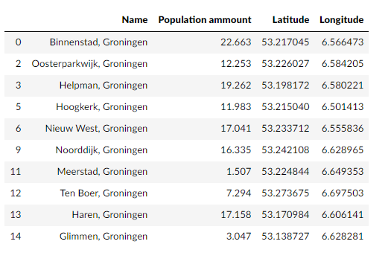

**Table 2: geographical data of Leeuwarden**

